ONLINE COMPLAIN MANAGEMENT

INTRODUCTION
The Online Complaint Management System is designed to simplify how users register their issues and how administrators manage them. In a world driven by feedback and instant responses, this system bridges the gap between the complainant and the management. Built using JavaFX for its graphical interface and MySQL for database handling, it offers a smooth and intuitive experience. Users can easily submit their complaints, while administrators can review them in real time. The addition of a “Resolved” checklist helps track complaint status seamlessly. This not only reduces manual work but also promotes transparency. With a clean interface and logical flow, it’s a perfect mini-project to demonstrate database integration and GUI handling in Java.

PROJECT DESCRIPTION

The Online Complaint Management System is a desktop-based application developed using JavaFX for the graphical user interface and MySQL as the backend database. The primary goal of this system is to streamline the process of lodging, storing, and resolving complaints in an organized and transparent manner. It provides an efficient bridge between users who register their grievances and administrators who manage and act upon them.When the application launches, users are greeted with a simple home screen offering two choices — User or Administrator. Regular users can easily file a new complaint by entering their name and description of the issue, which then gets stored securely in the database through JDBC connectivity. This ensures that every complaint is recorded permanently and can be retrieved later for review or action.On the other side, administrators can log in through a password-protected panel to view all submitted complaints in a clean, tabular view. Each complaint is accompanied by a “Resolved” checkbox, allowing the administrator to mark tasks as completed once the issue has been addressed. This resolved status is instantly updated in the database, ensuring real-time accuracy. The design is simple yet powerful, eliminating the need for paper-based systems and manual tracking.The project focuses on database-driven application development, combining user interface design, backend management, and data handling — all core aspects of modern computing. Its modular structure, real-time data updates, and smooth navigation make it a highly practical and educational mini-project. It can be easily extended for use in schools, colleges, or small organizations to handle feedback, complaints, or suggestions effectively.In essence, this project highlights the importance of technology in enhancing communication, accountability, and problem resolution — all while demonstrating the power of JavaFX and MySQL integration in creating professional, user-friendly solutions.

SYSTEM ARCHITECTURE
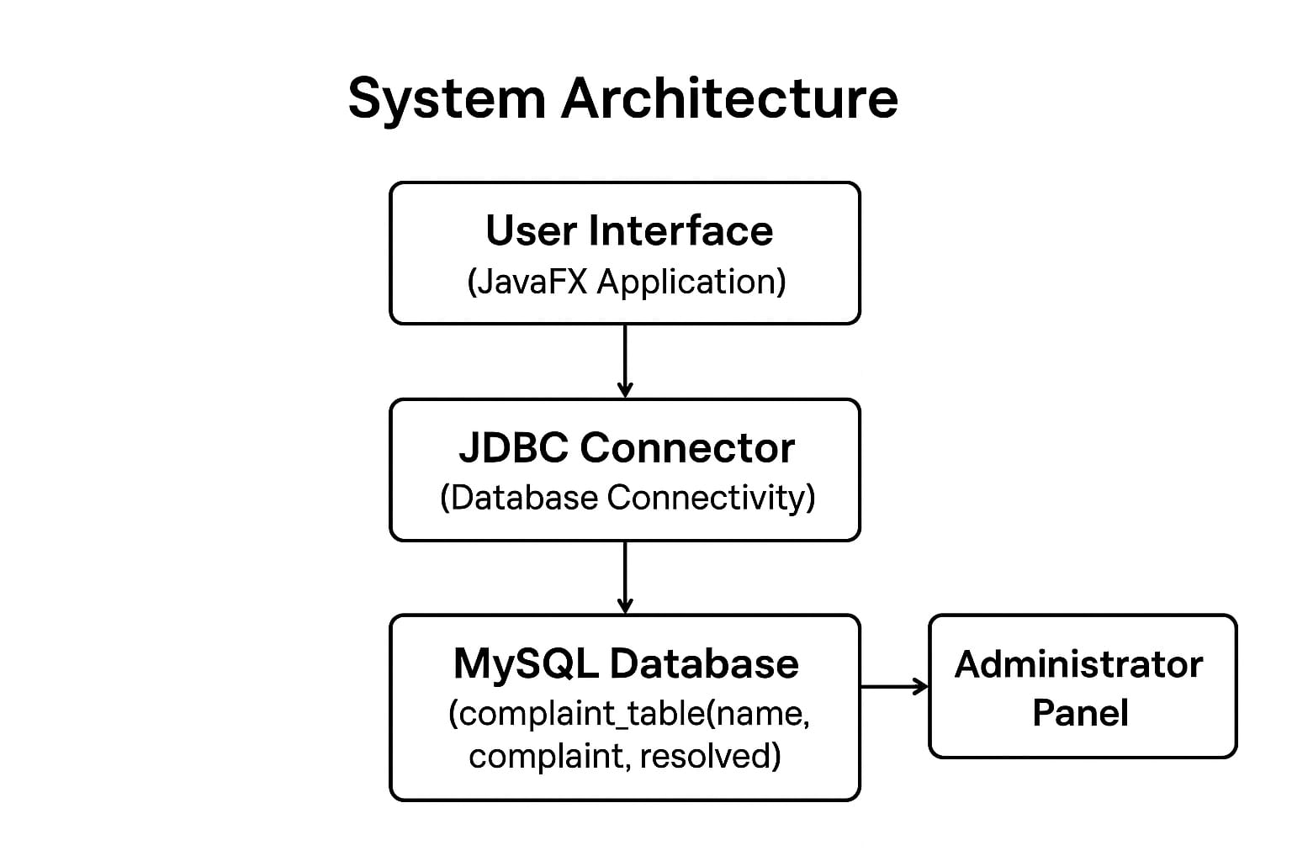
CODING

package complaint;
import javafx.application.Application;
import javafx.beans.property.*;
import javafx.collections.FXCollections;
import javafx.collections.ObservableList;
import javafx.geometry.Insets;
import javafx.scene.Scene;
import javafx.scene.control.*;
import javafx.scene.control.cell.CheckBoxTableCell;
import javafx.scene.control.cell.PropertyValueFactory;
import javafx.scene.layout.GridPane;
import javafx.scene.layout.VBox;
import javafx.stage.Stage;
import java.sql.*;
public class complaint_form extends Application {
Connection con;
public void connectDB() {
try {
con = DriverManager.getConnection(
"jdbc:mysql://localhost:3306/complaints", "root", "amirthaa_10102006");
} catch (SQLException e) {
e.printStackTrace();
}
}

@Override
public void start(Stage stage) {
connectDB();
Label roleLabel = new Label("Select Role:");
Button adminBtn = new Button("Administrator");
Button userBtn = new Button("User");
VBox roleLayout = new VBox(10, roleLabel, adminBtn, userBtn);
roleLayout.setPadding(new Insets(20));
Scene roleScene = new Scene(roleLayout, 300, 150);
stage.setTitle("Online Complaint Management");
stage.setScene(roleScene);
stage.show();
adminBtn.setOnAction(e -> adminLogin(stage));
userBtn.setOnAction(e -> userForm(stage));
}
private void adminLogin(Stage stage) {
Label passLabel = new Label("Enter Password:");
PasswordField passField = new PasswordField();
Button loginBtn = new Button("Login");
GridPane loginGrid = new GridPane();
loginGrid.setPadding(new Insets(20));
loginGrid.setVgap(10);
loginGrid.setHgap(10);
loginGrid.add(passLabel, 0, 0);
loginGrid.add(passField, 1, 0);
loginGrid.add(loginBtn, 1, 1);
Scene loginScene = new Scene(loginGrid, 350, 150);
stage.setScene(loginScene);

loginBtn.setOnAction(e -> {
String password = passField.getText();
if (password.equals("admin123")) {
showAllComplaints(stage);
} else {
Alert alert = new Alert(Alert.AlertType.ERROR, "Incorrect Password!");
alert.show();
}
});
}
private void showAllComplaints(Stage stage) {
TableView<Complaint> table = new TableView<>();
ObservableList<Complaint> data = FXCollections.observableArrayList();

TableColumn<Complaint, String> nameCol = new TableColumn<>("Name");
nameCol.setCellValueFactory(new PropertyValueFactory<>("name"));

TableColumn<Complaint, String> complaintCol = new TableColumn<>("Complaint");
complaintCol.setCellValueFactory(new PropertyValueFactory<>("complaint"));

TableColumn<Complaint, Boolean> resolvedCol = new TableColumn<>("Resolved");
resolvedCol.setCellValueFactory(new PropertyValueFactory<>("resolved"));
resolvedCol.setCellFactory(CheckBoxTableCell.forTableColumn(resolvedCol));
resolvedCol.setEditable(true);

table.getColumns().addAll(nameCol, complaintCol, resolvedCol);
table.setEditable(true);

try {
String sql = "SELECT * FROM complaint_table";
Statement stmt = con.createStatement();
ResultSet rs = stmt.executeQuery(sql);
while (rs.next()) {
int id = rs.getInt("id");
String name = rs.getString("name");
String complaint = rs.getString("complaint");
boolean resolved = rs.getBoolean("resolved");
Complaint c = new Complaint(id, name, complaint, resolved);

c.resolvedProperty().addListener((obs, oldVal, newVal) -> {
try {
PreparedStatement pst = con.prepareStatement(
"UPDATE complaint_table SET resolved=? WHERE id=?");
pst.setBoolean(1, newVal);
pst.setInt(2, c.getId());
pst.executeUpdate();
} catch (SQLException ex) {
ex.printStackTrace();
}
});
data.add(c);
}
} catch (SQLException e) {
e.printStackTrace();
}

table.setItems(data);

Button backBtn = new Button("Back");
backBtn.setOnAction(e -> start(stage));

VBox layout = new VBox(10, table, backBtn);
layout.setPadding(new Insets(20));

Scene scene = new Scene(layout, 600, 400);
stage.setScene(scene);
}

private void userForm(Stage stage) {
Label nameLabel = new Label("Name:");
TextField nameField = new TextField();
Label compLabel = new Label("Complaint:");
TextArea compField = new TextArea();
Button submitBtn = new Button("Submit");
Button backBtn = new Button("Back");

submitBtn.setOnAction(e -> {
try {
String sql = "INSERT INTO complaint_table(name, complaint) VALUES (?, ?)";
PreparedStatement pst = con.prepareStatement(sql);
pst.setString(1, nameField.getText());
pst.setString(2, compField.getText());
pst.executeUpdate();
Alert alert = new Alert(Alert.AlertType.INFORMATION, "Complaint Registered Successfully!");
alert.show();
nameField.clear();
compField.clear();
} catch (SQLException ex) {
ex.printStackTrace();
}
});

backBtn.setOnAction(e -> start(stage));

GridPane grid = new GridPane();
grid.setPadding(new Insets(20));
grid.setVgap(10);
grid.setHgap(10);

grid.add(nameLabel, 0, 0);
grid.add(nameField, 1, 0);
grid.add(compLabel, 0, 1);
grid.add(compField, 1, 1);
grid.add(submitBtn, 1, 2);
grid.add(backBtn, 1, 3);

Scene scene = new Scene(grid, 400, 300);
stage.setScene(scene);
}

public static class Complaint {
private final int id;
private final StringProperty name;
private final StringProperty complaint;
private final BooleanProperty resolved;

public Complaint(int id, String name, String complaint, boolean resolved) {
this.id = id;
this.name = new SimpleStringProperty(name);
this.complaint = new SimpleStringProperty(complaint);
this.resolved = new SimpleBooleanProperty(resolved);
}

public int getId() { return id; }
public String getName() { return name.get(); }
public String getComplaint() { return complaint.get(); }
public boolean isResolved() { return resolved.get(); }

public StringProperty nameProperty() { return name; }
public StringProperty complaintProperty() { return complaint; }
public BooleanProperty resolvedProperty() { return resolved; }
}

public static void main(String[] args) {
launch(args);
}}

Database Requirements
CREATE DATABASE complaints;
USE complaints;
CREATE TABLE complaint_table (
id INT AUTO_INCREMENT PRIMARY KEY,
name VARCHAR(100),
complaint TEXT,
resolved BOOLEAN DEFAULT FALSE
);

SCREENSHOTS

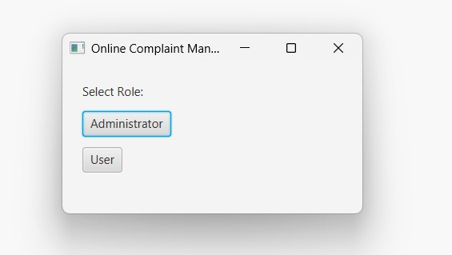

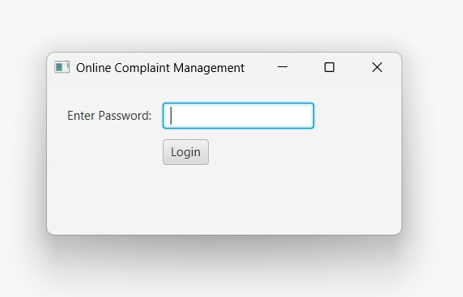

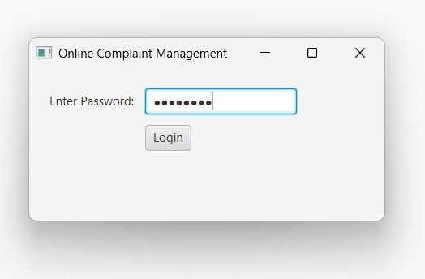

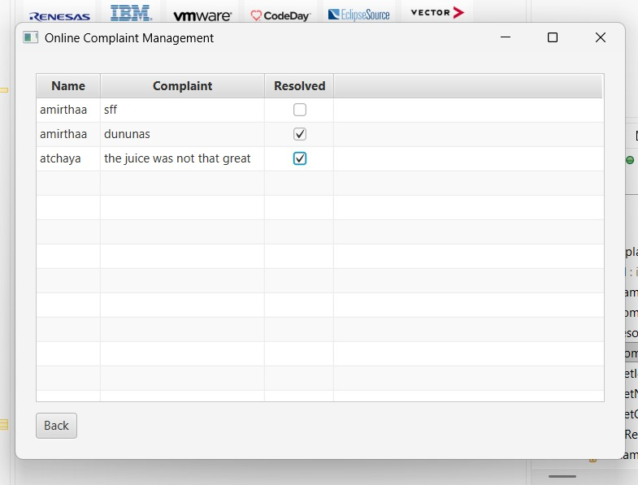

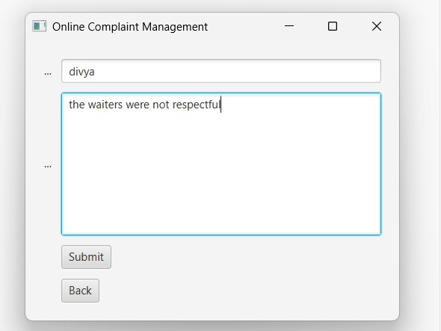

CONCLUSION
The Online Complaint Management System achieves its aim of simplifying complaint registration and tracking. It provides a user-friendly interface where users can easily submit grievances and administrators can monitor, review, and mark them as resolved. The inclusion of a checklist ensures better accountability and transparency in resolving issues. By bridging the communication gap between users and administrators, the system enhances efficiency and builds trust. The combination of JavaFX for an interactive interface and MySQL for robust data management demonstrates effective integration of front-end and back-end technologies. Overall, the project delivers a practical, efficient, and real-world-ready solution for digital complaint management.

FUTURE WORK
Future versions of this project can include features like unique login credentials for each user, enabling personalized dashboards. Notifications via email or SMS could alert users when their complaints are addressed. Administrators could have access to analytics dashboards displaying complaint trends and resolution rates over time. A search and filter system can also be added for quicker complaint lookup. Integrating this system with mobile apps or web platforms would make it more accessible and flexible. Additionally, implementing cloud storage could enhance data scalability and security for larger institutions.

PO-PSO MAPPING

PO/PSO | Description | Relevance (1–3)
PO1 | Apply knowledge of computing fundamentals and database systems | 3
PO2 | Identify, analyze, and define problems for effective solutions | 3
PO3 | Design and develop software components for real-time use | 3
PO4 | Use modern tools like JavaFX and MySQL for implementation | 3
PO5 | Understand professional responsibility and user experience | 2
PSO1 | Develop database-linked applications using Java | 3
PSO2 | Integrate GUI and backend logic efficiently | 3

JUSTIFICATION

PO/PSO | Description | Justification
PO1 | Apply knowledge of computing fundamentals and database systems. | The project applies core computing concepts through the use of JavaFX for GUI development and MySQL for database connectivity, demonstrating fundamental programming and database integration knowledge.
PO2 | Identify, analyze, and define computing problems for effective solutions. | The project identifies a real-world issue — inefficient complaint handling — and provides a structured digital solution that simplifies complaint registration and resolution.
PO3 | Design and develop software components for real-time use. | The system is designed as a functional application with two distinct modules (User and Administrator), both interacting with a live database to ensure real-time updates and data consistency.
PO4 | Use modern tools and technologies for software development. | The implementation of JavaFX (modern GUI framework) and JDBC (database connectivity API) reflects the use of advanced and industry-relevant tools for software creation.
PO5 | Understand professional and ethical responsibilities while delivering solutions. | By incorporating secure access for administrators and user-friendly design, the project emphasizes confidentiality, accuracy, and responsibility in managing user data.
PSO1 | Develop applications integrating database and front-end interfaces. | The project successfully connects a graphical interface (JavaFX) with a MySQL backend using JDBC, demonstrating seamless interaction between UI and database.
PSO2 | Implement effective problem-solving through analytical and logical programming. | Logical coding practices are used to validate inputs, manage data insertion, and update complaint statuses efficiently, showcasing analytical and problem-solving skills.

